MONGODB ASSIGNMENT WEEK-3

NAME: RENU YASWITHA CH

REG.NO: 22BCE20343

CAMPUS: VIT-AP

QUESTIONS BASED ON UPDATE , AGGREGATE FUNCTIONS

Q1. The total revenue generated from all sales

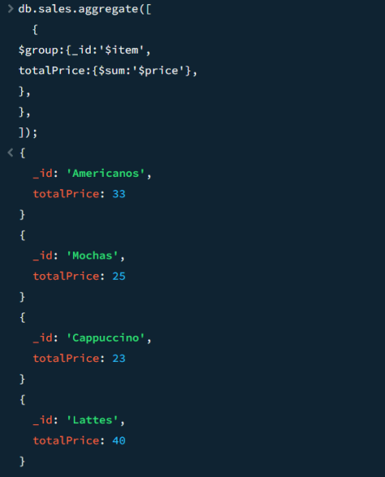

Q2. How many “Americanos” were sold in total?

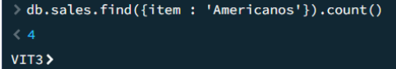

Q3. Increase the price of “Lattes” by 5 units

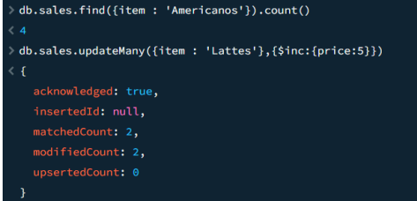

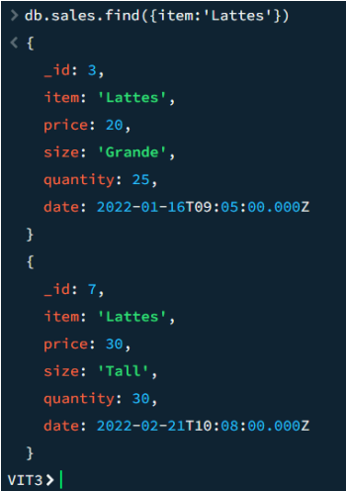

Q4. Unset the “size” field for all records where the price is less than 10

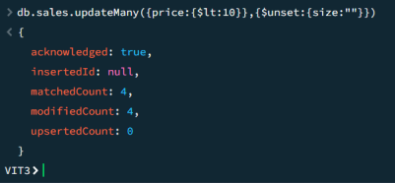

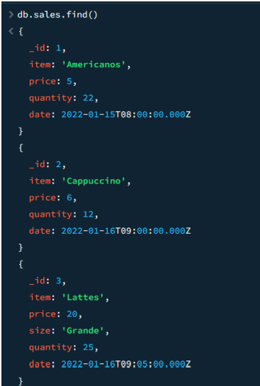

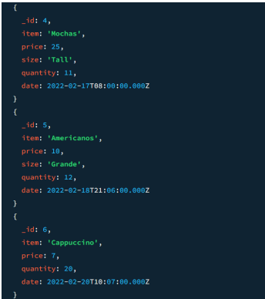

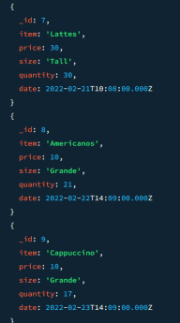

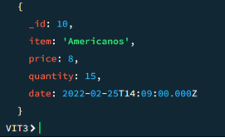

Q5. Find the average quantity sold for each item where the price is greater than $10, then sort these averages in descending order, skip the first result, and limit the output to 2 items.

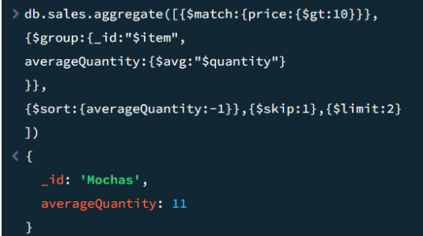

Q6. Identify the total quantity sold for each item, but only include those items where the maximum price recorded is at least $25. Then, sort the results by the total quantity in ascending order and limit the result to 1 item.

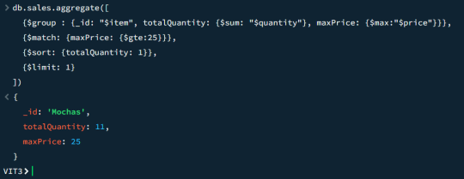

QUERIES RELATED TO INDEXING :

